# Appendix A

# F:\Os meus documentos\Universidade\Dissertação\Escrita\working\inprocess\images\insert-rule_usd.bmp

Figure A.1 - USD for Insert Rule Use Case

# Appendix B.

UML Class Diagram

# F:\Os meus documentos\Universidade\Dissertação\Escrita\working\inprocess\images\UMLClassDiagram.bmp

Figure B.1 – UML CLASS DIAGRAM

# Appendix C

UML Use cases

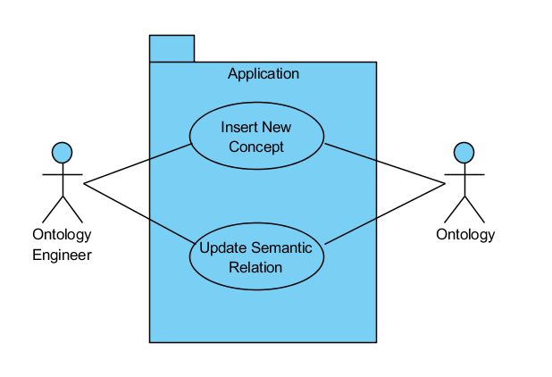

Figure C.1 - Main requirements UUC

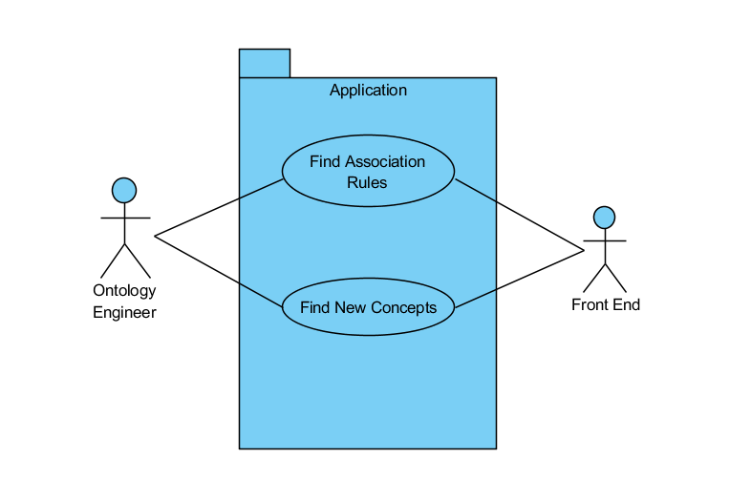

Figure C.2 - Front-End UUC

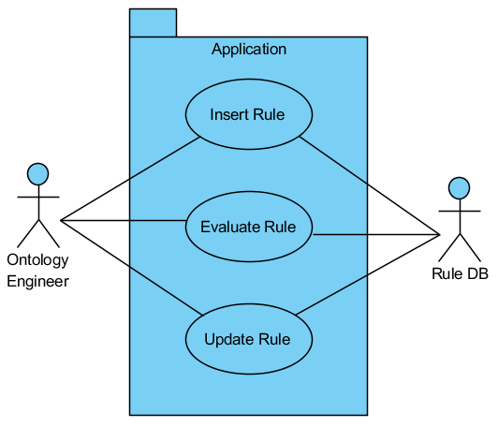

Figure C.3 - Rule DB UUC

# Appendix D

Table D.1 - List of all the rules discovered in Association Rules Discovery Process

|  |  |  |  |  |  |  |  |  |  |
| --- | --- | --- | --- | --- | --- | --- | --- | --- | --- |
| # | Premise | Conclusion | Confidence | Conviction | Gain | Laplace | Lift | Ps | Total Support |
| 1 | manag | wast | 0.6667 | 2.2500 | -0.4000 | 0.9231 | 2.6667 | 0.1250 | 0.2000 |
| 2 | wast | manag | 0.8000 | 3.5000 | -0.3000 | 0.9600 | 2.6667 | 0.1250 | 0.2000 |
| 3 | manag | recycl | 0.6667 | 2.2500 | -0.4000 | 0.9231 | 2.6667 | 0.1250 | 0.2000 |
| 4 | recycl | manag | 0.8000 | 3.5000 | -0.3000 | 0.9600 | 2.6667 | 0.1250 | 0.2000 |
| 5 | manag | wast\_manag | 0.6667 | 2.4000 | -0.4000 | 0.9231 | 3.3333 | 0.1400 | 0.2000 |
| 6 | wast\_manag | manag | 1.0000 | Infinity | -0.2000 | 1.0000 | 3.3333 | 0.1400 | 0.2000 |
| 7 | manag | plan | 0.6667 | 2.4000 | -0.4000 | 0.9231 | 3.3333 | 0.1400 | 0.2000 |
| 8 | plan | manag | 1.0000 | Infinity | -0.2000 | 1.0000 | 3.3333 | 0.1400 | 0.2000 |
| 9 | manag | implement | 0.6667 | 2.4000 | -0.4000 | 0.9231 | 3.3333 | 0.1400 | 0.2000 |
| 10 | implement | manag | 1.0000 | Infinity | -0.2000 | 1.0000 | 3.3333 | 0.1400 | 0.2000 |
| 11 | energi | consumpt | 0.8333 | 4.2000 | -0.3500 | 0.9615 | 2.7778 | 0.1600 | 0.2500 |
| 12 | consumpt | energi | 0.8333 | 4.2000 | -0.3500 | 0.9615 | 2.7778 | 0.1600 | 0.2500 |
| 13 | energi | temperatur | 0.6667 | 2.2500 | -0.4000 | 0.9231 | 2.6667 | 0.1250 | 0.2000 |
| 14 | temperatur | energi | 0.8000 | 3.5000 | -0.3000 | 0.9600 | 2.6667 | 0.1250 | 0.2000 |
| 15 | energi | indoor | 0.6667 | 2.2500 | -0.4000 | 0.9231 | 2.6667 | 0.1250 | 0.2000 |
| 16 | indoor | energi | 0.8000 | 3.5000 | -0.3000 | 0.9600 | 2.6667 | 0.1250 | 0.2000 |
| 17 | energi | heat | 0.6667 | 2.2500 | -0.4000 | 0.9231 | 2.6667 | 0.1250 | 0.2000 |
| 18 | heat | energi | 0.8000 | 3.5000 | -0.3000 | 0.9600 | 2.6667 | 0.1250 | 0.2000 |
| 19 | energi | energi\_consumpt | 0.8333 | 4.5000 | -0.3500 | 0.9615 | 3.3333 | 0.1750 | 0.2500 |
| 20 | energi\_consumpt | energi | 1.0000 | Infinity | -0.2500 | 1.0000 | 3.3333 | 0.1750 | 0.2500 |
| 21 | energi | electr | 0.8333 | 4.5000 | -0.3500 | 0.9615 | 3.3333 | 0.1750 | 0.2500 |
| 22 | electr | energi | 1.0000 | Infinity | -0.2500 | 1.0000 | 3.3333 | 0.1750 | 0.2500 |
| 23 | energi | power | 0.6667 | 2.4000 | -0.4000 | 0.9231 | 3.3333 | 0.1400 | 0.2000 |
| 24 | power | energi | 1.0000 | Infinity | -0.2000 | 1.0000 | 3.3333 | 0.1400 | 0.2000 |
| 25 | energi | oper | 0.6667 | 2.4000 | -0.4000 | 0.9231 | 3.3333 | 0.1400 | 0.2000 |
| 26 | oper | energi | 1.0000 | Infinity | -0.2000 | 1.0000 | 3.3333 | 0.1400 | 0.2000 |
| 27 | energi | hvac | 0.6667 | 2.4000 | -0.4000 | 0.9231 | 3.3333 | 0.1400 | 0.2000 |
| 28 | hvac | energi | 1.0000 | Infinity | -0.2000 | 1.0000 | 3.3333 | 0.1400 | 0.2000 |
| 29 | energi | cool | 0.6667 | 2.4000 | -0.4000 | 0.9231 | 3.3333 | 0.1400 | 0.2000 |
| 30 | cool | energi | 1.0000 | Infinity | -0.2000 | 1.0000 | 3.3333 | 0.1400 | 0.2000 |
| 31 | consumpt | temperatur | 0.6667 | 2.2500 | -0.4000 | 0.9231 | 2.6667 | 0.1250 | 0.2000 |
| 32 | temperatur | consumpt | 0.8000 | 3.5000 | -0.3000 | 0.9600 | 2.6667 | 0.1250 | 0.2000 |
| 33 | consumpt | indoor | 0.8333 | 4.5000 | -0.3500 | 0.9615 | 3.3333 | 0.1750 | 0.2500 |
| 34 | indoor | consumpt | 1.0000 | Infinity | -0.2500 | 1.0000 | 3.3333 | 0.1750 | 0.2500 |
| 35 | consumpt | heat | 0.6667 | 2.2500 | -0.4000 | 0.9231 | 2.6667 | 0.1250 | 0.2000 |
| 36 | heat | consumpt | 0.8000 | 3.5000 | -0.3000 | 0.9600 | 2.6667 | 0.1250 | 0.2000 |
| 37 | consumpt | energi\_consumpt | 0.8333 | 4.5000 | -0.3500 | 0.9615 | 3.3333 | 0.1750 | 0.2500 |
| 38 | energi\_consumpt | consumpt | 1.0000 | Infinity | -0.2500 | 1.0000 | 3.3333 | 0.1750 | 0.2500 |
| 39 | consumpt | electr | 0.6667 | 2.2500 | -0.4000 | 0.9231 | 2.6667 | 0.1250 | 0.2000 |
| 40 | electr | consumpt | 0.8000 | 3.5000 | -0.3000 | 0.9600 | 2.6667 | 0.1250 | 0.2000 |
| 41 | consumpt | oper | 0.6667 | 2.4000 | -0.4000 | 0.9231 | 3.3333 | 0.1400 | 0.2000 |
| 42 | oper | consumpt | 1.0000 | Infinity | -0.2000 | 1.0000 | 3.3333 | 0.1400 | 0.2000 |
| 43 | consumpt | hvac | 0.6667 | 2.4000 | -0.4000 | 0.9231 | 3.3333 | 0.1400 | 0.2000 |
| 44 | hvac | consumpt | 1.0000 | Infinity | -0.2000 | 1.0000 | 3.3333 | 0.1400 | 0.2000 |
| 45 | consumpt | cool | 0.6667 | 2.4000 | -0.4000 | 0.9231 | 3.3333 | 0.1400 | 0.2000 |
| 46 | cool | consumpt | 1.0000 | Infinity | -0.2000 | 1.0000 | 3.3333 | 0.1400 | 0.2000 |
| 47 | wast | recycl | 1.0000 | Infinity | -0.2500 | 1.0000 | 4.0000 | 0.1875 | 0.2500 |
| 48 | recycl | wast | 1.0000 | Infinity | -0.2500 | 1.0000 | 4.0000 | 0.1875 | 0.2500 |
| 49 | wast | wast\_manag | 0.8000 | 4.0000 | -0.3000 | 0.9600 | 4.0000 | 0.1500 | 0.2000 |
| 50 | wast\_manag | wast | 1.0000 | Infinity | -0.2000 | 1.0000 | 4.0000 | 0.1500 | 0.2000 |
| 51 | wast | plan | 0.8000 | 4.0000 | -0.3000 | 0.9600 | 4.0000 | 0.1500 | 0.2000 |
| 52 | plan | wast | 1.0000 | Infinity | -0.2000 | 1.0000 | 4.0000 | 0.1500 | 0.2000 |
| 53 | toilet | sanitari | 0.8000 | 4.0000 | -0.3000 | 0.9600 | 4.0000 | 0.1500 | 0.2000 |
| 54 | sanitari | toilet | 1.0000 | Infinity | -0.2000 | 1.0000 | 4.0000 | 0.1500 | 0.2000 |
| 55 | temperatur | indoor | 0.8000 | 3.7500 | -0.3000 | 0.9600 | 3.2000 | 0.1375 | 0.2000 |
| 56 | indoor | temperatur | 0.8000 | 3.7500 | -0.3000 | 0.9600 | 3.2000 | 0.1375 | 0.2000 |
| 57 | temperatur | heat | 0.8000 | 3.7500 | -0.3000 | 0.9600 | 3.2000 | 0.1375 | 0.2000 |
| 58 | heat | temperatur | 0.8000 | 3.7500 | -0.3000 | 0.9600 | 3.2000 | 0.1375 | 0.2000 |
| 59 | temperatur | energi\_consumpt | 0.8000 | 3.7500 | -0.3000 | 0.9600 | 3.2000 | 0.1375 | 0.2000 |
| 60 | energi\_consumpt | temperatur | 0.8000 | 3.7500 | -0.3000 | 0.9600 | 3.2000 | 0.1375 | 0.2000 |
| 61 | temperatur | hvac | 0.8000 | 4.0000 | -0.3000 | 0.9600 | 4.0000 | 0.1500 | 0.2000 |
| 62 | hvac | temperatur | 1.0000 | Infinity | -0.2000 | 1.0000 | 4.0000 | 0.1500 | 0.2000 |
| 63 | temperatur | cool | 0.8000 | 4.0000 | -0.3000 | 0.9600 | 4.0000 | 0.1500 | 0.2000 |
| 64 | cool | temperatur | 1.0000 | Infinity | -0.2000 | 1.0000 | 4.0000 | 0.1500 | 0.2000 |
| 65 | temperatur | climat | 0.8000 | 4.0000 | -0.3000 | 0.9600 | 4.0000 | 0.1500 | 0.2000 |
| 66 | climat | temperatur | 1.0000 | Infinity | -0.2000 | 1.0000 | 4.0000 | 0.1500 | 0.2000 |
| 67 | recycl | wast\_manag | 0.8000 | 4.0000 | -0.3000 | 0.9600 | 4.0000 | 0.1500 | 0.2000 |
| 68 | wast\_manag | recycl | 1.0000 | Infinity | -0.2000 | 1.0000 | 4.0000 | 0.1500 | 0.2000 |
| 69 | recycl | plan | 0.8000 | 4.0000 | -0.3000 | 0.9600 | 4.0000 | 0.1500 | 0.2000 |
| 70 | plan | recycl | 1.0000 | Infinity | -0.2000 | 1.0000 | 4.0000 | 0.1500 | 0.2000 |
| 71 | offic | offic\_build | 0.8000 | 4.0000 | -0.3000 | 0.9600 | 4.0000 | 0.1500 | 0.2000 |
| 72 | offic\_build | offic | 1.0000 | Infinity | -0.2000 | 1.0000 | 4.0000 | 0.1500 | 0.2000 |
| 73 | indoor | heat | 0.8000 | 3.7500 | -0.3000 | 0.9600 | 3.2000 | 0.1375 | 0.2000 |
| 74 | heat | indoor | 0.8000 | 3.7500 | -0.3000 | 0.9600 | 3.2000 | 0.1375 | 0.2000 |
| 75 | indoor | energi\_consumpt | 0.8000 | 3.7500 | -0.3000 | 0.9600 | 3.2000 | 0.1375 | 0.2000 |
| 76 | energi\_consumpt | indoor | 0.8000 | 3.7500 | -0.3000 | 0.9600 | 3.2000 | 0.1375 | 0.2000 |
| 77 | indoor | hvac | 0.8000 | 4.0000 | -0.3000 | 0.9600 | 4.0000 | 0.1500 | 0.2000 |
| 78 | hvac | indoor | 1.0000 | Infinity | -0.2000 | 1.0000 | 4.0000 | 0.1500 | 0.2000 |
| 79 | indoor | cool | 0.8000 | 4.0000 | -0.3000 | 0.9600 | 4.0000 | 0.1500 | 0.2000 |
| 80 | cool | indoor | 1.0000 | Infinity | -0.2000 | 1.0000 | 4.0000 | 0.1500 | 0.2000 |
| 81 | heat | energi\_consumpt | 0.8000 | 3.7500 | -0.3000 | 0.9600 | 3.2000 | 0.1375 | 0.2000 |
| 82 | energi\_consumpt | heat | 0.8000 | 3.7500 | -0.3000 | 0.9600 | 3.2000 | 0.1375 | 0.2000 |
| 83 | heat | hvac | 0.8000 | 4.0000 | -0.3000 | 0.9600 | 4.0000 | 0.1500 | 0.2000 |
| 84 | hvac | heat | 1.0000 | Infinity | -0.2000 | 1.0000 | 4.0000 | 0.1500 | 0.2000 |
| 85 | heat | cool | 0.8000 | 4.0000 | -0.3000 | 0.9600 | 4.0000 | 0.1500 | 0.2000 |
| 86 | cool | heat | 1.0000 | Infinity | -0.2000 | 1.0000 | 4.0000 | 0.1500 | 0.2000 |
| 87 | energi\_consumpt | electr | 0.8000 | 3.7500 | -0.3000 | 0.9600 | 3.2000 | 0.1375 | 0.2000 |
| 88 | electr | energi\_consumpt | 0.8000 | 3.7500 | -0.3000 | 0.9600 | 3.2000 | 0.1375 | 0.2000 |
| 89 | energi\_consumpt | oper | 0.8000 | 4.0000 | -0.3000 | 0.9600 | 4.0000 | 0.1500 | 0.2000 |
| 90 | oper | energi\_consumpt | 1.0000 | Infinity | -0.2000 | 1.0000 | 4.0000 | 0.1500 | 0.2000 |
| 91 | energi\_consumpt | hvac | 0.8000 | 4.0000 | -0.3000 | 0.9600 | 4.0000 | 0.1500 | 0.2000 |
| 92 | hvac | energi\_consumpt | 1.0000 | Infinity | -0.2000 | 1.0000 | 4.0000 | 0.1500 | 0.2000 |
| 93 | energi\_consumpt | cool | 0.8000 | 4.0000 | -0.3000 | 0.9600 | 4.0000 | 0.1500 | 0.2000 |
| 94 | cool | energi\_consumpt | 1.0000 | Infinity | -0.2000 | 1.0000 | 4.0000 | 0.1500 | 0.2000 |
| 95 | electr | power | 0.8000 | 4.0000 | -0.3000 | 0.9600 | 4.0000 | 0.1500 | 0.2000 |
| 96 | power | electr | 1.0000 | Infinity | -0.2000 | 1.0000 | 4.0000 | 0.1500 | 0.2000 |
| 97 | wast\_manag | plan | 1.0000 | Infinity | -0.2000 | 1.0000 | 5.0000 | 0.1600 | 0.2000 |
| 98 | plan | wast\_manag | 1.0000 | Infinity | -0.2000 | 1.0000 | 5.0000 | 0.1600 | 0.2000 |
| 99 | hvac | cool | 1.0000 | Infinity | -0.2000 | 1.0000 | 5.0000 | 0.1600 | 0.2000 |
| 100 | cool | hvac | 1.0000 | Infinity | -0.2000 | 1.0000 | 5.0000 | 0.1600 | 0.2000 |
| 101 | coat\_materi | coat | 1.0000 | Infinity | -0.2000 | 1.0000 | 5.0000 | 0.1600 | 0.2000 |
| 102 | coat | coat\_materi | 1.0000 | Infinity | -0.2000 | 1.0000 | 5.0000 | 0.1600 | 0.2000 |